
And after these things, I looked, and behold,
a door standing open in heaven…

Revelation 4 & 5

by: Julie Jacobs

Music To The Glory of God
Revelation 4 and 5, is a choral work written and produced by MACS member Julie Jacobs. It is an opportunity for improvisational musicians and those who play “by ear,” to participate in the Church’s rich tradition of choral worship. “I wrote this musical in hopes that the contemporary Church would be able to experience what it’s like to be led in worship by a choir.” Revelation 4 and 5 takes its text directly from the New King James version of the Bible and is easy to learn. Even those who do not read music will be able to sing and play it in a few short practices.

The scene in the text of Revelation 4 and 5 is a worship service that takes place in heaven. It begins with John, the revelator, being invited to “come up here” by an angel. While he is in the Spirit, he sees an open door in heaven. Immediately he is in the presence of God in the throne room of heaven. He describes what he sees, the actual throne of God and those that surround it. They are eternally worshiping God. Then he becomes involved in the search for One who is worthy to open the scroll that is in the right hand of God. Finally, after an extensive search in which no one is found worthy to open the scroll, it is discovered that the “Lamb who was slain” is worthy, because He purchased people for God with His blood. Thus ensues a worship service extolling the worthiness of the Lamb who was slain to receive power, wisdom, glory, honor, strength and blessing. It is truly magnificent.

Julie Jacobs is a graduate of Christ for the Nations in Dallas, Texas, where the musical was done for the first time in 1997. Since that time, she has helped several Churches perform the musical, usually around the holidays and Easter.

The enhanced CD for Revelation 4 and 5 was recorded and mixed at Easy Street Studios in Maple Grove, MN, owned by Christian couple Greg and Darla Hill. The goal is to have the musical in several area Churches in the greater Metropolitan area.

The Production package for Revelation 4 & 5 will include the recorded version, a split track CD, production notes and a video that can be used in Churches with a projection system in conjunction with the performance. It will be available for sale at CD Baby: http://www.cdbaby.com/juliejacobs2
and http://rcmi.us the website for Rivertown Christian Ministries International, (RCMI) that is sponsoring the project.

Julie says, “Thank you for your faithful prayers and giving toward this and other RCMI projects, making it possible to move forward with this anointed worship piece. Also, let us know if your Church would like a copy.” You can reach Julie at Julie@music2glory.com.

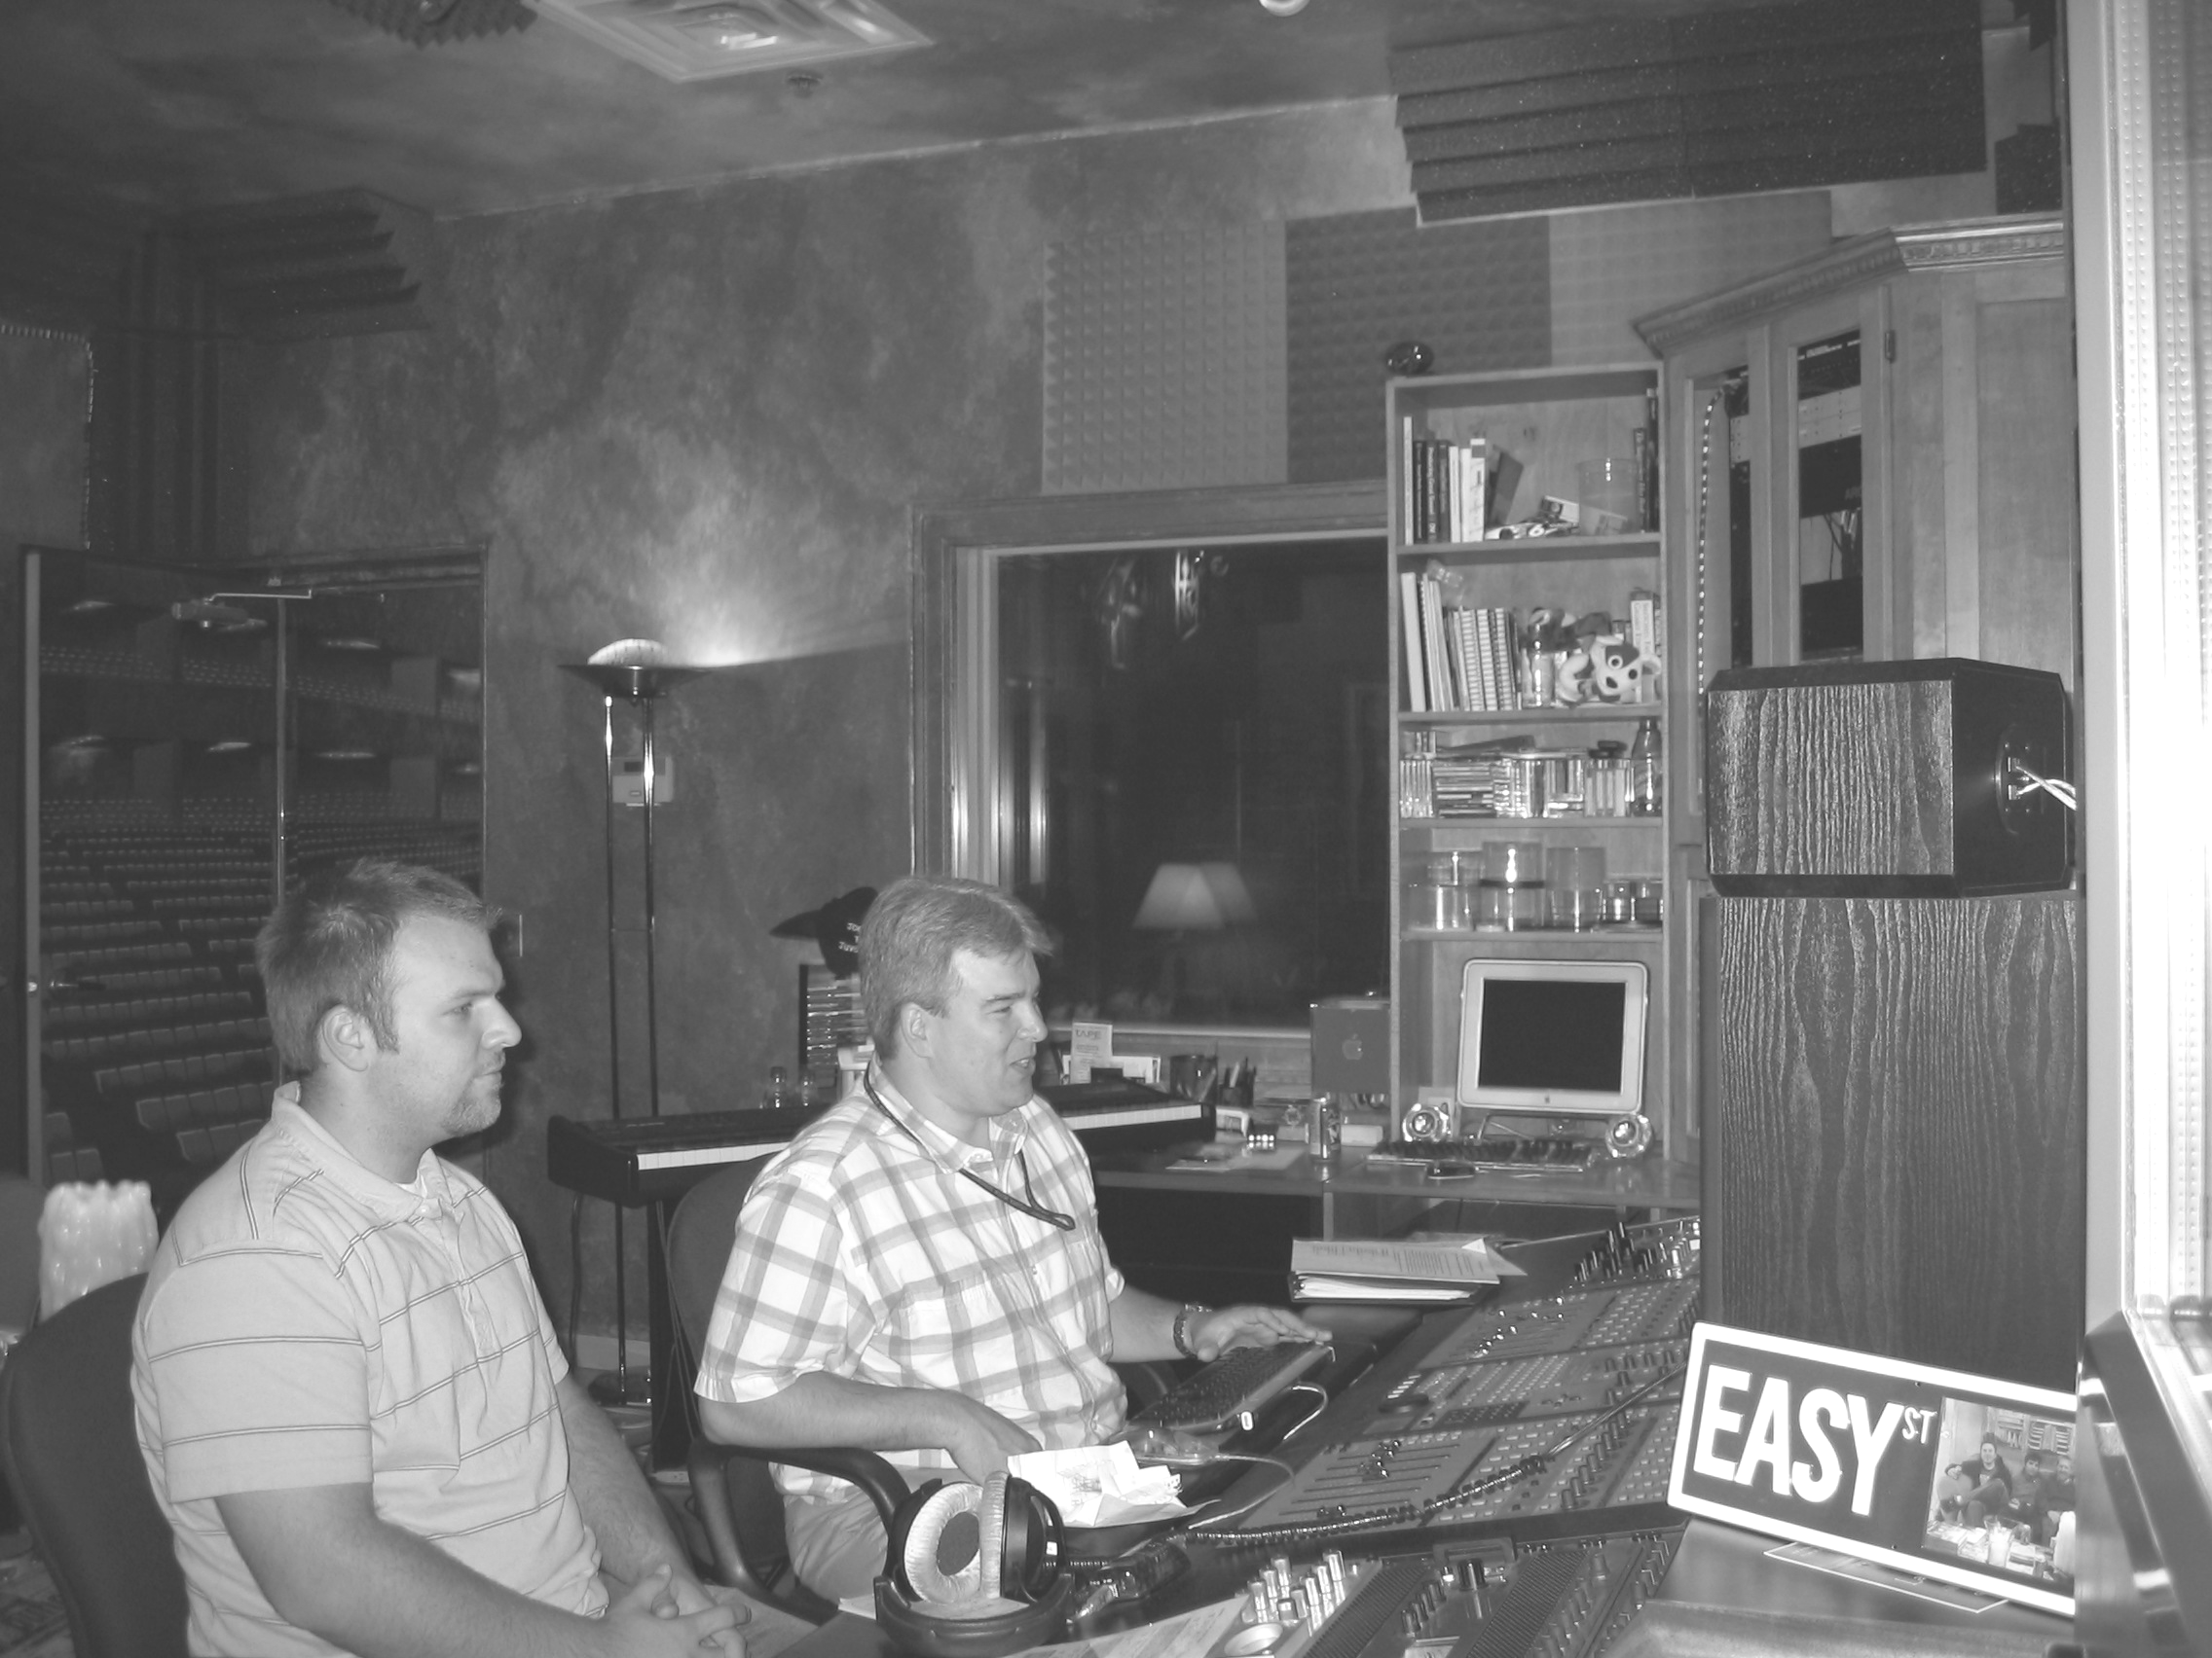
Artwork for Revelation 4 & 5 available as art prints, teaching aids and video from Revelation Illustrated http://www.revelationillustrated.com courtesy of Pat Marvenko Smith, 1-800-327-7330

Greg Hill (Right) and his assistant, at the helm of his ProTools console Julie Jacobs with her husband, Robb.
mixing the Revelation 4 & 5 project. Easy Street Studios, Maple Grove, MN.

